KAMBALA SAI SURENDRA

SUMMARY  PROJECT |  | •  •  • | Having basic knowledge in HTML, CSS, Bootstrap, JavaScript, React Js, Redux and jQuery.  Have very good analytical thinking and hands-on in React Js, Redux, Bootstrap.  Well acquainted with version control repository (GitHub).
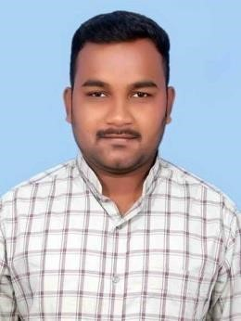
Mandepeta

SUMMARY

Title | Keeper-App  Github-link:”https://github.com/surendrakambala/Keeperapp”
Technologies Involved | HTML, CSS, JavaScript ,React Js
Summary | Storing notes as we required.
 | Adding and Deleting of notes procedure is created by using JS.
Responsibilities | Creating own web page using React Js, HTML,, JavaScript. Handling adding and deleting notes by using JavaScript.

Project#1

mA

Title | Facebook Front-End Design Using React Js  Github-link:”https://github.com/surendrakambala/facebook”
Technologies Involved | HTML, React Js, Material UI
Summary | - Some part of Facebook website is created by using React Js.  - Login using valid credentials by using Firebase service as backend database.  - Posts are created by using Firebase Database.
Responsibilities | Doing webpages setup from scratch. Creating different Components in JSX files

Project#2

EDUCATION

JNTU, KAKINADA

2015 – 2018

B.Tech in Computer Science and Engineering
Obtained a percentage of 63.80%

LEELA KRISHNA BABUJI POLYTECHNIC, RAVULAPALEM

2011 – 2014

Diploma Computer Engineer
Obtained a percentage of 68.03 %

ZP High School,Tapeswaram

2001 – 2011

Matriculation
Obtained a percentage of 62 %

TECHNICAL PROFICIENCIES
DEVELOPMENT: React Js, Redux, HTML, CSS, Bootstrap, jQuery, JavaScript.
IDE EXPERIENCE: Visual Studio Code (VSCODE).

LANGUAGES: JAVA.
OPERATING SYSTEM: Windows XP ,7,8,10.

ACADEMIC PARTICIPATIONS
- Appreciated certificate in “CYBERTHON-2K18” from East Godavari conducted by “APITA”. • Worked as COORDINATOR in College Annual Fest.
- Participated in “Paper Presentation” on “Ethical Hacking” in EPROZYNE2K15 conducted at Pragati Engineering College.
- Participated in “Poster Presentation” on “Google Glass” in EPROZYNE-2K16 conducted at Pragati Engineering College.

PERSONAL

DETAILS

Date of Birth: | 15 Mar, 1996
Languages Known: | Telugu, English
Sex: | Male

DECLARATION

I hereby solemnly affirm that all the details provided above are always true to the best of my knowledge and belief and that, I shall carry myself in a manner that lends dignity to the organization and worthy enough of the person.

